**SETTINGS**

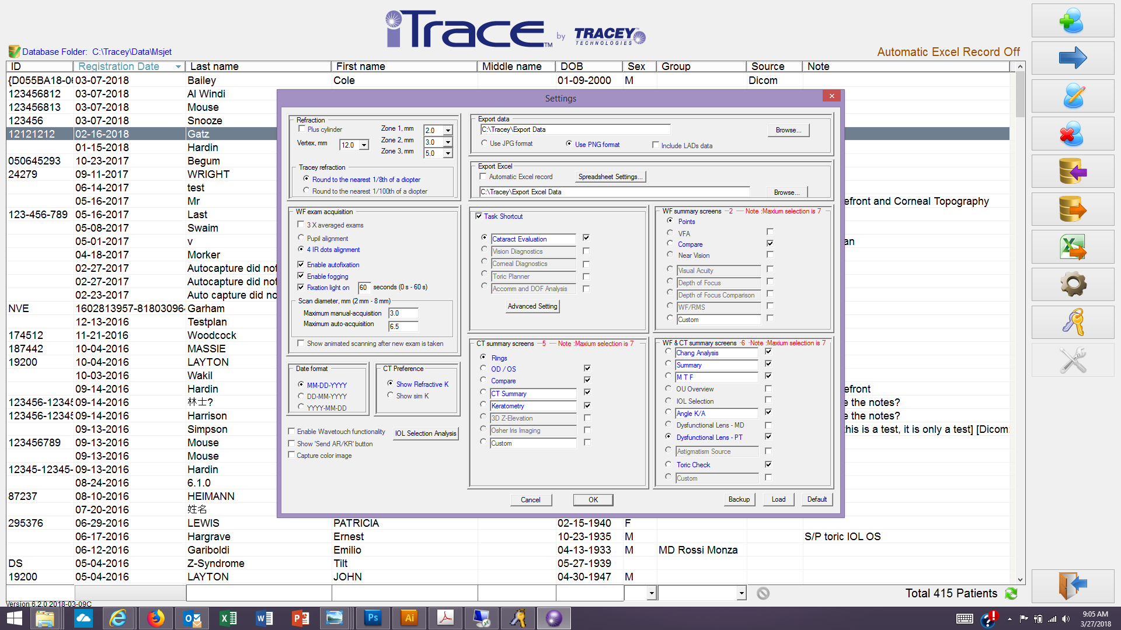

**Changes:**

CT Screens -

Select: Rings, OD/OS, Compare, CT Summary and Keratometry.

Rings is initial default.

WF screens –

Select: Points, Compare.

Points is initial default.

WF&CT Screens -

Select: Chang Analysis, Summary, M T F (new custom screen name created from Visual Acuity display), Angle K/A, Dysfunctional Lens – PT and Toric check.

Dysfunctional Lens – PT is the initial default.

**Cataract Task Settings:**

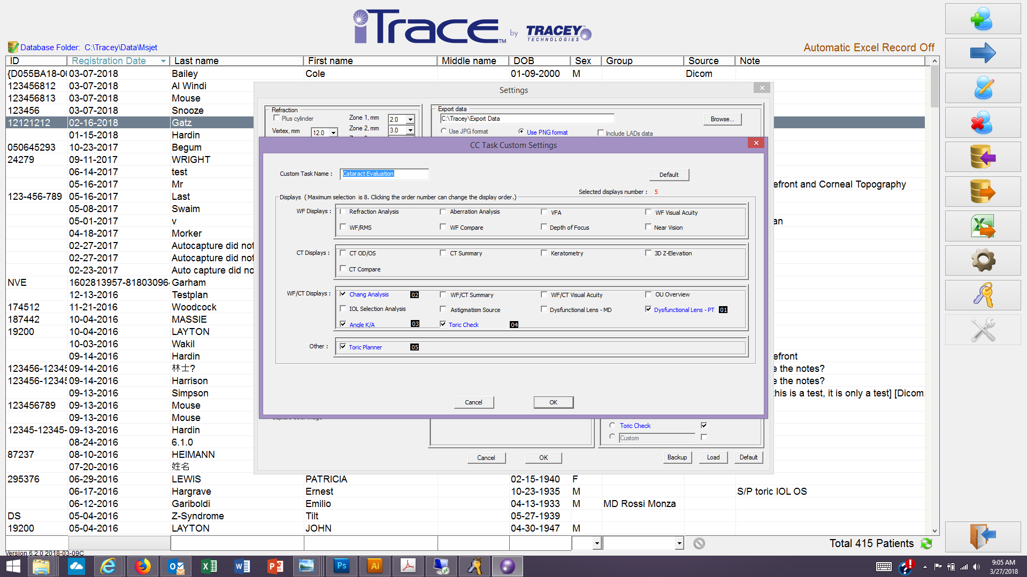

Ensure Toric Check is selected and is set at item #4.

**DISPLAYS**

**DLI-PT:**

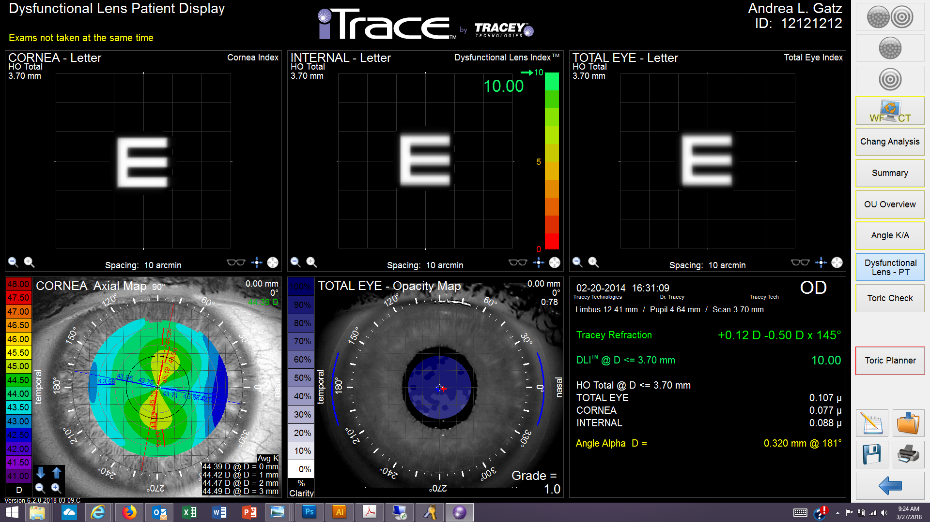

Changes:

Opacity map panel – show eye image, limbus and vertex.

**M T F:**

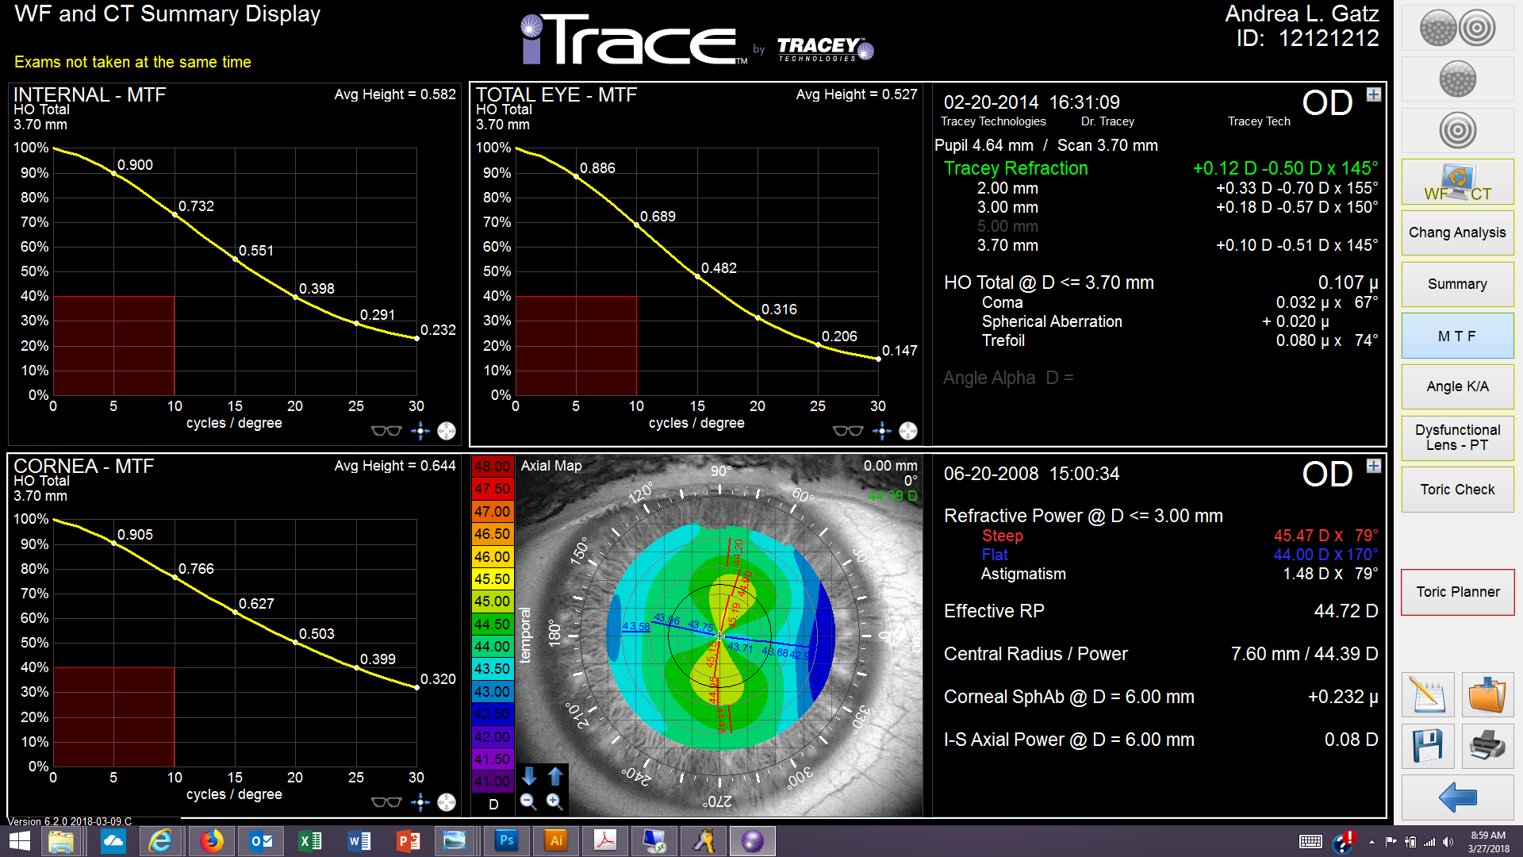

Set panels to display MTF HO Total.

**CT Summary:**

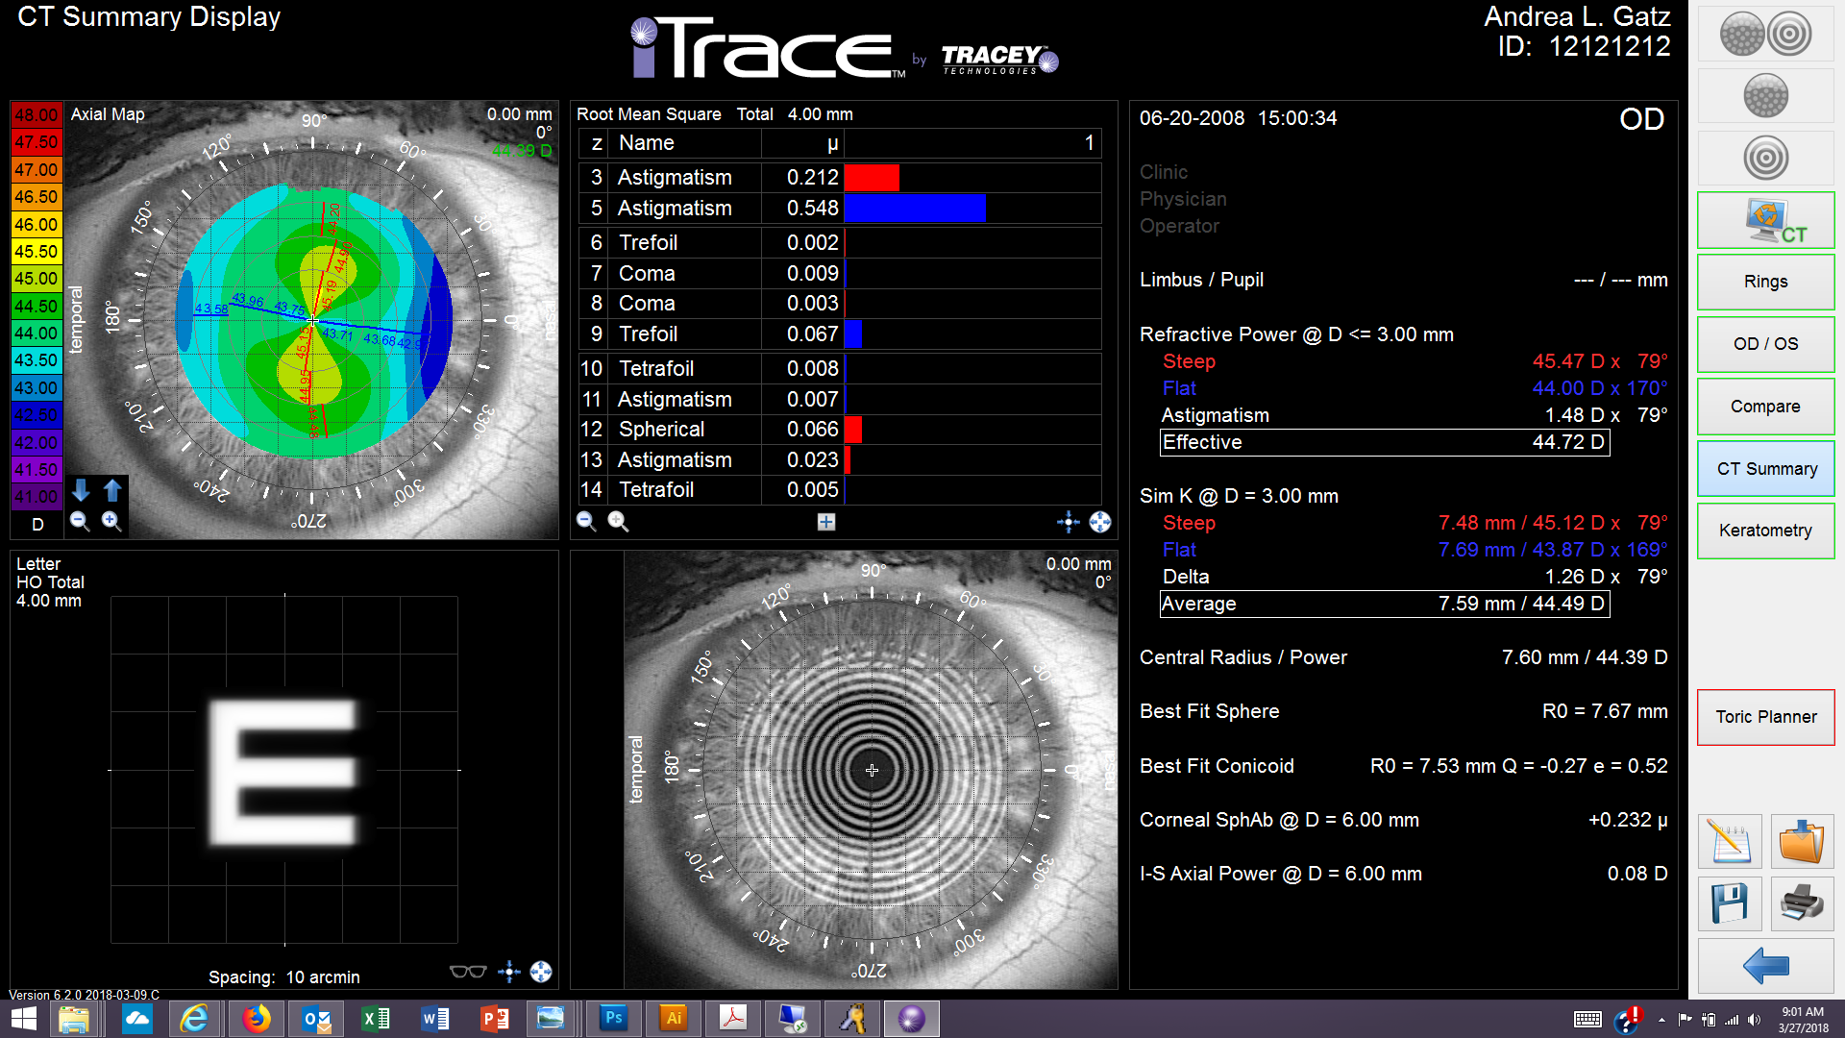

**Changes:**

Top left panel – Axial map, show map, eye image and Keratometry overlay

Top Right panel – Root Mean Square at 4.00 mm zone size

Bottom Left panel – Visual Acuity Chart, Letter E, size 20/100, with HO Total and a 4.00mm zone size

Bottom right panel – Eye Image only.